Guide Purpose and Overview:

This guide explains how to complete staff rosters for youth activities. It also describes how to use the preformatted Google Sheets roster templates provided by the Office of Youth Protection (OYP) in your Simple Safe Zone (SSZ) shared drive.

Staff Roster Overview and Instructions:

Introduction | This topic defines the columns found in the preformatted youth activity Staff Roster.  Rosters must be uploaded to youth activity Simple Safe Zone (SSZ) a minimum of 14 days prior to the start of the youth activity.
What is a staff roster? | A staff roster:  - Lists the names of the activity staff who work with youth participants for any length of time during the activity, and  - Dates for completion of required screening and training.  Staff rosters demonstrate compliance with screening, training, and supervision ratios.
Simple Safe Zone (SSZ) roster template | Each youth activity’s Simple Safe Zone (SSZ) Google Shared drive includes a staff roster as a preformatted Google Sheet. Rosters should be updated annually to reflect current staffing plans. Google Sheets is a spreadsheet application like Microsoft Excel.  Rosters submitted to OYP: Use the preformatted roster in SSZ or use a spreadsheet from another application. Staff rosters in any format should include at minimum all required columns provided on the SSZ staff roster. This allows OYP to verify compliance with youth protection standards and archive common rosters.
Guidelines for using the SSZ staff roster | This section explains how to navigate and use the staff roster spreadsheet, including its tabs, column rules, and built-in error checks.  Tabs: The staff roster includes four tabs. The “Staff” tab is the roster itself. Read the “About” tab to learn about the others.  Columns and column names: Do not edit the preformatted column names, delete columns, or rearrange columns. You may freeze and hide columns. Use additional columns after the provided columns for information specific to your program, if desired.  Cell validation: The spreadsheet allows you to leave cells blank. Some columns include validation that will stop you if the cell value is out of range or in the wrong format. Other validation places a red triangle in the corner of the cell. Select the triangle to read the error message.

Staff Roster Columns: Diagrams and Definitions

This section provides diagrams and explanations for the staff roster, along with sample records to help you understand how to complete it:

- Tables below each diagram define the columns and their purposes.
- Note: Do not edit any text that is formatted white on black.

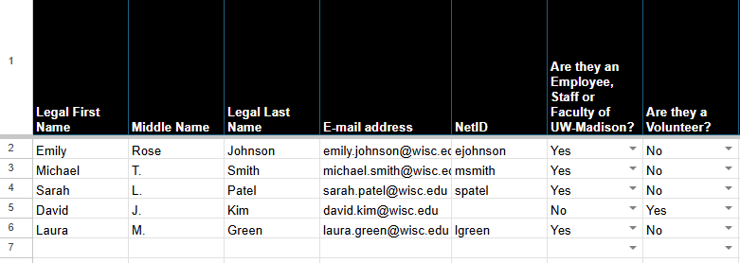

Column Name | Definition or Purpose
Staff Name & Information
A. Legal First Name | Use the name that appears in an HR record. The name fields appear on reports and allow a search by staff name.
B. Middle Name | (Optional) Middle Name helps resolve duplicate names and appears on reports.
C. Legal Last Name | Use the name that appears in an HR record. The name fields appear on reports and allow a search by staff name.
Email address | The Email address is used by OYP to track and report training completion data. When possible, staff are encouraged to use a UW-Madison issued email address to register for compliance training.
F. NetID | The NetID is used by the staff person to register for staff training through the OHRD catalog and by OYP to track and report training statistics. The NetID helps to resolve duplicate names.
Fa Are they an employee, staff or faculty of UW-Madison? | Type or select “Yes” if the individual is an employee, staff or faculty of UW-Madison. This field is used for compliance reporting. Type or select “No” for individuals who are not.
Are they a Volunteer? | Type or select “Yes” if the individual is a volunteer. This field is used for compliance reporting. Type or select “No” for individuals who are not.  Note: Volunteers are individuals who perform duties related to a youth activity with no promise, expectation, or receipt of compensation for services rendered. Volunteers do not include university staff who are being paid to perform university services or "other duties as assigned." Guest speakers are also not typically classified as university volunteers.

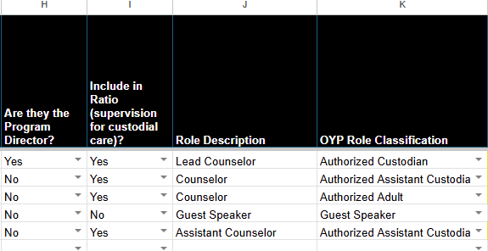

Column Name | Definition or Purpose
Youth Interaction Role
G. Is Program Director? | Type or select “Yes” if the individual is the Program Director or a program administrator who uses an Assistant Director or Associate Director title. This field is used for compliance reporting. Leave the field blank or type or select “No” for individuals with other staff positions.
H. Include in Ratio? | Type or select “Yes” if the individual is counted in the program’s staff-to-participant supervision ratio (is either an Authorized Custodian or Authorized Assistant Custodian). This field is used to compute the ratio and define training requirements. Staff who are not counted in the ratio must not have unsupervised access to participants. Leave the field blank or type or select “No” for individuals who are not counted in the supervision ratio (Authorized Adults or Guest Speakers).
I. Role Description | This free text entry field indicates the staff person’s role in the program and can be a position title or short description.
OYP Role Classification | Select the OYP Role Classification that matches the person’s role in the program (Authorized Custodian, Authorized Assistant Custodian, Authorized Adult, or Guest Speaker). This field is used to confirm training completion based on the person’s role.  Note: Screening and training requirements will be highlighted in yellow based on role classification selection. If unsure of OYP classification, refer to the Training and Resources page on the OYP website. Reach out to OYP for additional assistance.

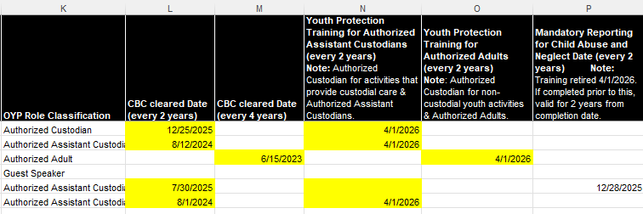

Column Name | Definition or Purpose
Required Staff Screenings refer to Staff Trainings - Office of Youth Protection (wisc.edu)
N. CBC Cleared Date | The Criminal Background Check Cleared Date is the date that divisional HR indicates an employee or candidate has passed a CBC. This date is used in compliance reporting. (Required)  Note: Individuals who work with youth must have a valid CBC with the Position of Trust with Access to Vulnerable Populations designation (POTAVP) on file. Authorized Custodians and Assistant Authorized Custodians are required to have a valid CBC within the last 2 years. Authorized Adults are required to have a valid CBC within the last 4 years.
Required Staff Screenings refer to Staff Trainings - Office of Youth Protection (wisc.edu)
Youth Protection Training for Authorized Assistant Custodians (every 2 years) | The completion date of Youth Protection Training for Authorized Assistant Custodians is used in compliance reporting.  (Required for Authorized Custodian for activities that provide custodial care and Authorized Assistant Custodians)  Note: This training replaces the mandated reporter training and reflects new youth protection requirements from System Administration.
Youth Protection Training for Authorized Adults  (every 2 years) | The completion date of Youth Protection Training for Authorized Adults is used in compliance reporting.  (Required for Authorized Custodian for non-custodial youth activities and Authorized Adults).  Note: This training replaces the mandated reporter training and reflects new youth protection requirements from System Administration.
Mandatory Reporting for Child Abuse and Neglect Date (Every 2 years) | The completion date of Wisconsin Mandated Reporter Online Training (for child abuse or neglect) is used in compliance reporting.  (Required for Authorized Custodians, Authorized Assistant Custodians and Authorized Adults)  Note: This training was retired on April 1st, 2026. If you completed it before that date, it remains valid for two years from your completion date.
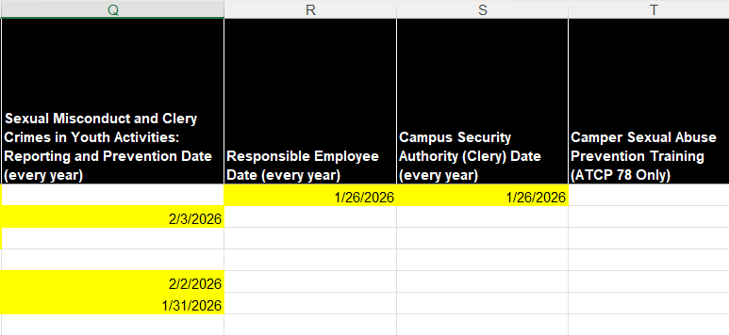

S. Sexual Misconduct and Clery Crimes in Youth Activities: Reporting and Prevention Date (Every year) | The completion date for this online training is used in compliance reporting.  (Required for Authorized Assistant Custodians)
V. Responsible Employee Date  (Every year) | The completion date for online Responsible Employee training is used in compliance reporting. (Required for Authorized Custodians)
W. Campus Security Authority (Clery) Date (Every year) | The completion date for online Campus Security Authority training is used in compliance reporting (Required for Authorized Custodians).
Camper Sexual Abuse Prevention Training (Every year) | The completion date for online or in-person Camper Sexual Abuse Prevention Training is used for compliance reporting.  (Required for Authorized Custodians and Authorized Assistant Custodians)  Note: Required for ATCP 78 Residential Youth Activities.

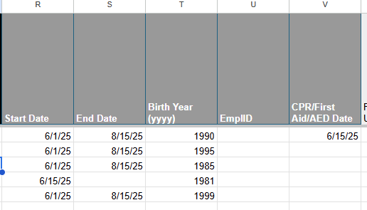

Column Name | Definition or Purpose
Additional Staff Information
Start Date | (Optional) Enter the date the staff member began working with the youth  activity. This helps OYP confirm when screening and training requirements first apply.
End Date | (Optional) Enter the date the staff member stopped working with the activity. This helps OYP confirm when screening and training requirements apply, especially for year-round programs.
Birth Year (YYYY) | (Optional) The birth year helps to resolve duplicate names and is used to compute age differential between staff and participants.
Empl ID | (Optional) The Employee ID helps to resolve duplicate names. If part of an authorized investigation, it enables investigators to locate HRS information.
CPR/First Aid/AED Date  (if applicable) | CPR/First Aid/AED Date  Note: May be applicable (i.e.: ATCP 78 Residential Activities that take a trip off-site). Contact OYP with questions.

Need Help?
- In a Google Doc or Sheet, click Help > Help Topics
- For SSZ questions, email: youthprotection@wisc.edu

