Staff Roster Column Definitions
updated January 2023
Introduction | This topic defines the columns on the youth program staff roster.
What is a staff roster? | A staff roster lists the names of the program staff (Authorized Adults and Designated Individuals) who work with youth participants for any length of time during the program, along with the dates for completion of required screening and training. Staff rosters demonstrate compliance with screening, training, and supervision ratios.
Simple Safe Zone (SSZ) roster template | Each youth activity’s 2023 Simple Safe Zone (SSZ) Google Shared drive includes a staff roster as a preformatted Google Sheet. Google Sheets is a spreadsheet application like Microsoft Excel.  Rosters submitted to OYP: Use the preformatted roster in SSZ or use a spreadsheet from another application. Staff rosters in any format should include the same columns provided on the SSZ staff roster. This allows OYP to verify compliance with youth protection standards and archive common rosters.
Guidelines for using the SSZ staff roster | Tabs: The staff roster includes four tabs. Read the “About” tab to learn about the others. The “Staff” tab is the roster itself. Drag this tab to the first position so that it displays when you open the file.  Columns and column names: Do not edit the preformatted column names, delete columns, or rearrange columns. You may freeze and hide columns. Use additional columns after the provided columns for information specific to your program, if desired.  Cell validation: The spreadsheet allows you to leave cells blank. Some columns include validation that will stop you if the cell value is out of range or in the wrong format. Other validation places a red triangle in the corner of the cell. Select the triangle to read the error message.
Diagrams and definitions | The following diagrams show the staff roster with sample records. The first diagram shows the entire sheet, while the following diagrams show only the records. The tables below each diagram define the columns.

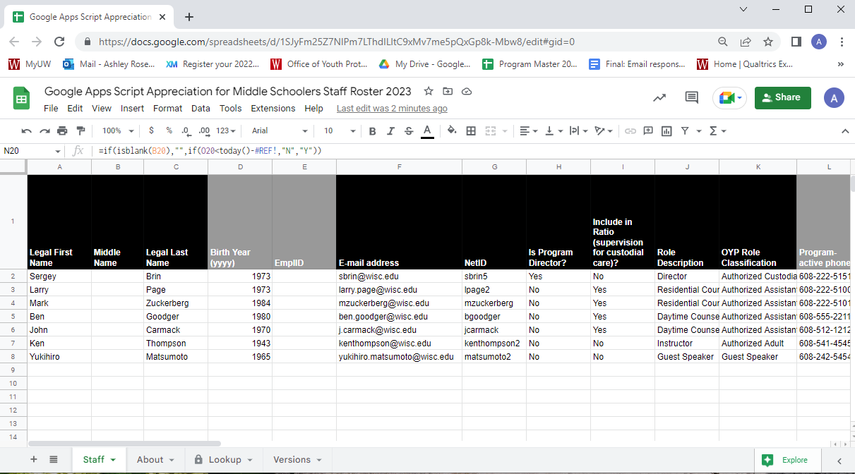
Column Name | Definition or Purpose
Staff Identity
A. Legal First Name | Use the name that appears in an HR record. The name fields appear on reports and allow a search by staff name.
B. Middle Name | (Optional) The Middle Name helps resolve duplicate names and appears on reports.
C. Legal Last Name | Use the name that appears in an HR record. The name fields appear on reports and allow a search by staff name.
D. Birth Year | The birth year helps to resolve duplicate names and is used to compute age differential between staff and participants.

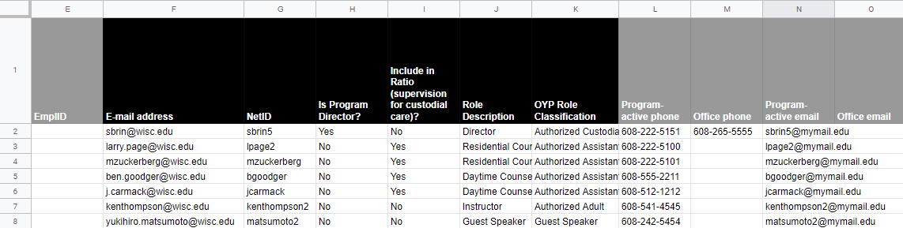

Column Name | Definition or Purpose
HR System of Record
E. EmplID | The Employee ID helps to resolve duplicate names. If part of an authorized investigation, it enables investigators to locate HRS information.
F. NetID | The NetID is used by the staff person to register for staff training through the OHRD catalog and by OYP to track and report training statistics. The NetID helps to resolve duplicate names.
Youth Interaction Role
G. Is Program Director? | Type or select “Yes” if the individual is the Program Director or a program administrator who uses an Assistant Director or Associate Director title. This field is used for compliance reporting. Leave the field blank or type or select “No” for individuals with other staff positions.
H. Include in Ratio? | Type or select “Yes” if the individual is counted in the program’s staff-to-participant supervision ratio (is either an Authorized Custodian or Authorized Assistant Custodian). This field is used to compute the ratio and define training requirements. Staff who are not counted in the ratio must not have unsupervised access to participants. Leave the field blank or type or select “No” for individuals who are not counted in the supervision ratio (Authorized Adults or Guest Speakers).
I. Role Description | This free text entry field indicates the staff person’s role in the program and can be a position title or short description.
OYP Role Classification | Select the OYP Role Classification that matches the person’s role in the program (Authorized Custodian, Authorized Assistant Custodian, Authorized Adult, Guest Speaker). This field is used to confirm training completion based on the person’s role.

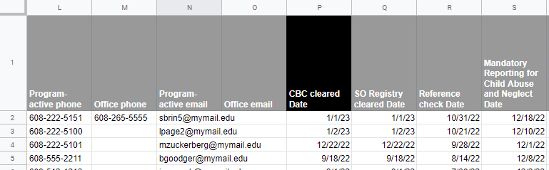

Column Name | Definition or Purpose
Staff Contact Information
J. Program-active phone | (Optional) A phone number that can be reached during programming in the event of an emergency or urgent communication.
K. Office phone | (Optional) A preferred phone number for general communication outside of programming time.
L. Program-active email | An email address that can be reached during programming in the event of an emergency or urgent communication.
M. Office email | (Optional) A preferred email address for general communication outside of programming time.
Required Staff Screenings refer to Staff Trainings - Office of Youth Protection (wisc.edu)
N. CBC Cleared Date | The Criminal Background Check Cleared Date is the date that divisional HR indicates an employee or candidate has passed a CBC. This date is used in compliance reporting.
O. SO Registry Cleared Date | The Sex Offender Registry Cleared Date is the date that divisional HR indicates an employee or candidate has passed a check of the SO registry. This date is used in compliance reporting.
P. Reference Check Date | The date that the Program Director or divisional HR completes required reference checks on candidates for new program staff.

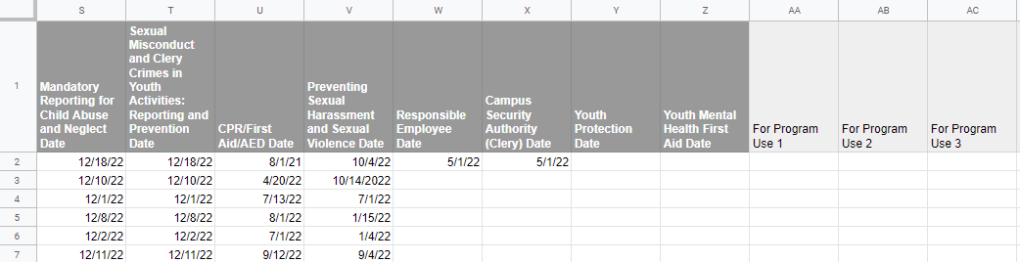

Column Name | Definition or Purpose
Required Staff Screenings refer to Staff Trainings - Office of Youth Protection (wisc.edu)
Q. Mandatory Reporting for EO54 Date | The completion date of Wisconsin Mandated Reporter Online Training (for child abuse or neglect) is used in compliance reporting.
S. Sexual Misconduct and Clery Crimes in Youth Activities: Reporting and Prevention Date | The completion date for this in-person training is used in compliance reporting.
T. CPR/First Aid/AED Date | CPR/First Aid/AED Date
U. Preventing Sexual Harassment and Sexual Violence Date | The completion date for this in-person training is used in compliance reporting.
V. Responsible Employee Date | The completion date for online Responsible Employee training is used in compliance reporting. (required for Authorized Custodians)
W. Campus Security Authority (Clery) Date | The completion date for online Campus Security Authority training is used in compliance reporting (required for Authorized Custodians).
Youth Protection Date | The completion date for this in-person training is used in compliance reporting. Training not available in 2023.
Youth Mental Health First Aid | The completion date for this in-person training is used in compliance reporting. Training not available in 2023.

