Participant Roster Column Definitions
updated: January 2023
Introduction | This topic defines the columns on the youth program participant roster.
What is a participant roster? | A participant roster lists the names of the youth participants in a program along with parent or guardian and emergency contact information. Participant rosters are archived and demonstrate compliance with OYP, campus partner, and other requirements.
Simple Safe Zone (SSZ) roster template | Each youth activity’s 2023 Simple Safe Zone (SSZ) Google Shared drive includes a participant roster as a preformatted Google Sheet. Google Sheets is a spreadsheet application like Microsoft Excel.  Rosters submitted to OYP: Use the preformatted roster in SSZ or use a spreadsheet from another application. Participant rosters in any format should include the same columns provided on the SSZ participant roster. This allows OYP to verify compliance and archive common rosters. OYP understands that the information include on your submitted roster is limited to the information that you have collected for 2023.
Guidelines for using the SSZ staff roster | Tabs: The participant roster includes four tabs. Read the “About” tab to learn about the others. The “Staff” tab is the roster itself. Drag this tab to the first position so that it displays when you open the file.  Columns and column names: Do not edit the preformatted column names, delete columns, or rearrange columns. You may freeze and hide columns. Use additional columns after the provided columns for information specific to your program, if desired.  Cell validation: The spreadsheet allows you to leave cells blank. Some columns include validation that will stop you if the cell value is out of range or in the wrong format. Other validation places a red triangle in the corner of the cell. Select the triangle to read the error message.
Diagrams and definitions | The following diagrams show the participant roster with sample records. The first diagram shows the entire sheet, while the following diagrams show only the records. The tables below each diagram define the columns.

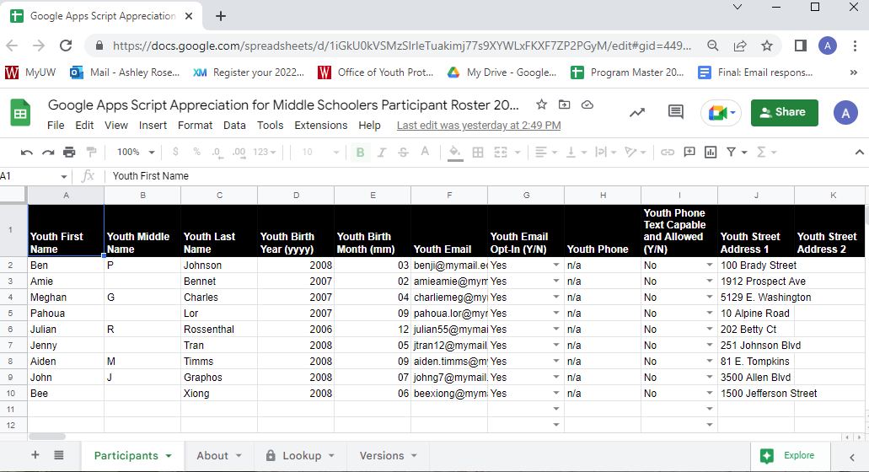

Column Name | Definition or Purpose
Participant Identity
A Youth First Name | Use the name provided at registration. Names are used by Risk Management for insurance and are archived.
B. Youth Middle Name | Youth Middle Name can be used to resolve duplicate names. (Optional)
C. Youth Last Name | Use the name provided at registration. Names are used by Risk Management for insurance and are archived.
D. Youth Birth Year (yyyy) | The birth year helps to resolve duplicate names, is used to compute age differential between staff and participants and is archived.
Youth Birth Month (mm) | The birth month helps to resolve duplicate names, is used to compute age differential between staff and participants and is archived.

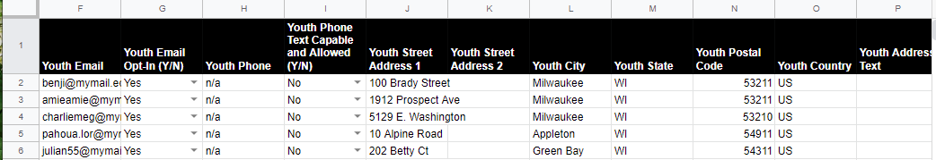
Column Name | Definition or Purpose
Participant Contact Information (OYP collects contact information for archive and to meet state licensing requirements.)
F. Youth Email | (Optional) Youth email is used for program and emergency communication and to resolve duplicate names.
G. Youth Email Opt-in | (Y/N input) Type “Yes” or select from drop down for Yes if you have permission from the parent/guardian to email the youth participant for non-operational purposes. Leave the cell blank or type “No” for No if you did not ask permission or if the parent/guardian declined.
H. Youth Phone | (Optional) Youth phone is used for program and emergency communication and to resolve duplicate names.
I. Youth Phone Text Capable and Allowed | (Y/N input) Type “Yes” or select from drop down for Yes if you have permission from the parent/guardian to send text messages to the youth participant for non-operational purposes. Leave the cell blank or type “No” for No if you did not ask permission or if the parent/guardian declined.
J. Youth Street Address 1 | Youth address information is archived.
K. Youth Street Address 2 | Youth address information is archived.
L. Youth City | Youth address information is archived.
M. Youth State | Youth address information is archived.
N. Youth Postal Code | Youth address information is archived.
O. Youth Country | Use country for international addresses.
P. Youth Address Text | Free text entry cell for international addresses that do not match the format of a U.S. address.

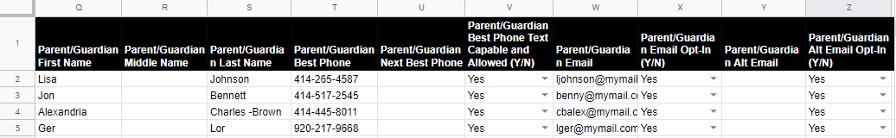
Column Name | Definition or Purpose
Parent/Guardian Identity
Q. Parent/Guardian First Name | Parent/Guardian names are used for emergency contact and are archived.
R. Parent/Guardian Middle Name | Parent/Guardian names are used for emergency contact and are archived.
S. Parent/Guardian Last Name | Parent/Guardian names are used for emergency contact and are archived.
Parent/Guardian Contact Information (OYP collects contact information for emergency communication, in case of a future investigation or inquiry, and to meet state licensing requirements.)
T. Parent/Guardian Best Phone | Best phone is the phone most likely to be answered during programming.  If the parent/guardian does not have phone access, then the emergency contact below must have phone access.
U. Parent/Guardian Next Best Phone | (Optional) Next best phone is a second option (like evening versus daytime) for reaching a parent/guardian during programming.
V. Parent/Guardian Best Phone Text Capable and Allowed | (Y/N input) Type “Yes” or select from drop down for Yes if you have permission to use text messaging for non-operational purposes. Otherwise, leave the cell blank or type “No” for No.
W. Parent/Guardian Email | Email may be used for program-specific and emergency communication before, during, and following programming.
X. Parent/Guardian Email Opt-In | (Y/N input) Type “Yes” or select from drop down for Yes if you have permission to email parent/guardian for non-operational purposes. Otherwise, leave the cell blank or type “No” for No.

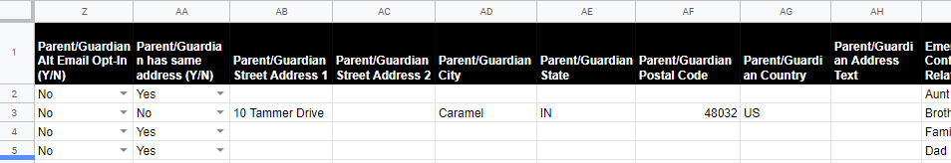
Y. Parent/Guardian Alt Email | (Optional) Use Alt Email if you choose to collect both work and personal email addresses or email addresses for more than one parent/guardian. Email may be used for program-specific and emergency communication before, during, and following programming.
Z. Parent/Guardian Alt Email Opt-In | (Y/N input) Type “Yes” for Yes if you have permission to email parent/guardian for non-operational purposes. Otherwise, leave the cell blank or type “n” for No.
AA. Parent/Guardian Has Same Address | (Y/N input) Type “Yes” for Yes if Parent/Guardian has the same address already listed for the youth participant. Otherwise, leave the cell blank or type “n” for No.  If the address is not the same, then complete the cells for the Parent/Guardian address.
AB. Parent/Guardian Street Address 1 | Parent/Guardian address information is archived. Leave cells blank if the Parent/Guardian has the same address as the youth participant.
AC. Parent/Guardian Street Address 2 | Parent/Guardian address information is archived. Leave cells blank if the Parent/Guardian has the same address as the youth participant.
AD. Parent/Guardian City | Parent/Guardian address information is archived. Leave cells blank if the Parent/Guardian has the same address as the youth participant.
AE. Parent/Guardian State | Parent/Guardian address information is archived. Leave cells blank if the Parent/Guardian has the same address as the youth participant.
AF. Parent/Guardian Postal Code | Parent/Guardian address information is archived. Leave cells blank if the Parent/Guardian has the same address as the youth participant.
AG. Parent/Guardian Country | Use country for international addresses.
AH. Parent/Guardian Address Text | Free text entry cell for international addresses that do not match the format of a U.S. address.

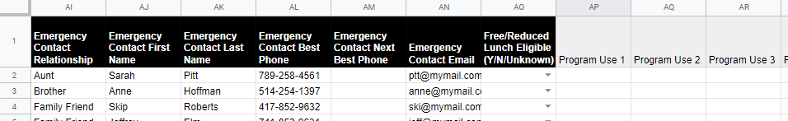
Column Name | Definition or Purpose
Emergency Contact Information
AI. Emergency Contact Relationship | Emergency Contact Relationship is the relationship of the contact person to the youth participant.
AJ. Emergency Contact First Name | Emergency Contact Names are used for emergency contact.
AK. Emergency Contact Last Name | Emergency Contact Names are used for emergency contact.
AL. Emergency Contact Best Phone | Best phone is the phone most likely to be answered during programming.  If the parent/guardian does not have phone access, then the emergency contact must have phone access.
AM. Emergency Contact Next Best Phone | (Optional) Next best phone is a second option (like evening vs daytime) for reaching an emergency contact during programming.
AN. Emergency Contact Email | (Optional) Email may be used for emergency communication during programming.
Participant DPI Eligibility (DPI information may be used to identify additional programs and candidates for scholarship eligibility.)
AO. Free/Reduced Lunch Eligible | (Optional) (Y/N/Unknown) Type “y” for Yes if participant is eligible. Type “u” for unknown, if you are tracking eligibility and don’t know. Otherwise, leave the cell blank or type “n” for No.

